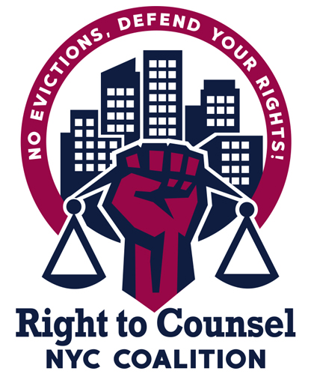

**RTC NYC Tool 12.4.7 Orientation for New Lawyers on Right to Counsel**

Sample Agenda (1 hour)

1. Introductions - name, gender pronouns, role/org, (10 mins)
2. Why did tenants fight for a right to counsel? Why did you fight for a right to counsel? (Tenant Leader) (5 mins)
3. Show the [trailer](https://www.youtube.com/watch?v=uiY4WrrA0iU&t=5s) to the RTCNYC documentary (2 mins)
4. How did the RTC coalition win Right to Counsel? What were the campaign tactics? (Tenant Organizer) (5 mins)
5. What role did lawyers play in the campaign? (Tenant Attorney) (5 mins)
6. Show the tenant leader video (3.5 mins)
7. What do you want to see from RTC attorneys? (Tenant Leader) (5 mins)
8. What is the RTC coalition organizing around now? Talk about cancel rent, housing courts must change, rent strike etc (Tenant Organizer) (5 mins)
9. What are the legal working groups in the RTC coalition working on? (Tenant Attorney) (5 mins)
10. Questions (15 mins)
11. Closing